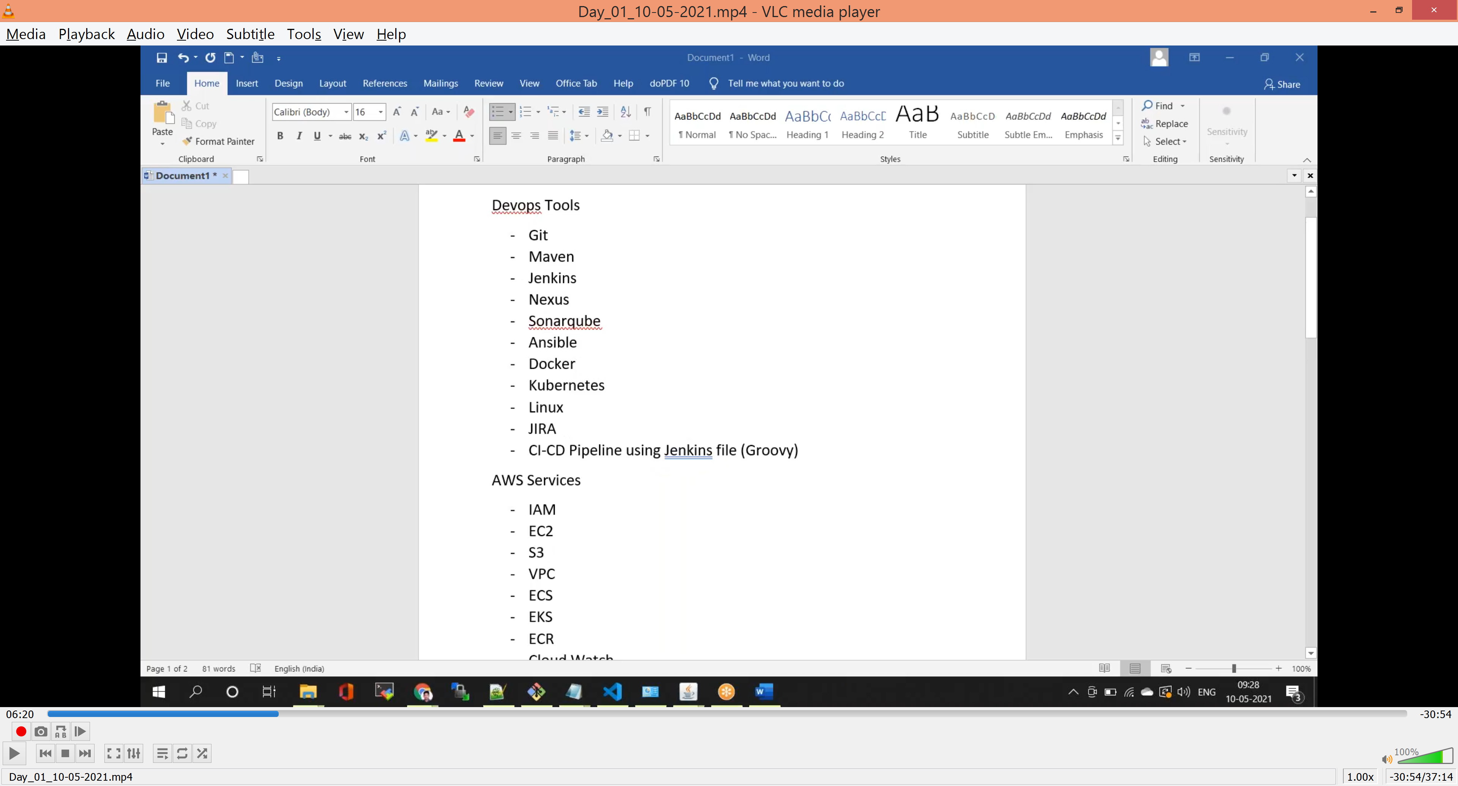

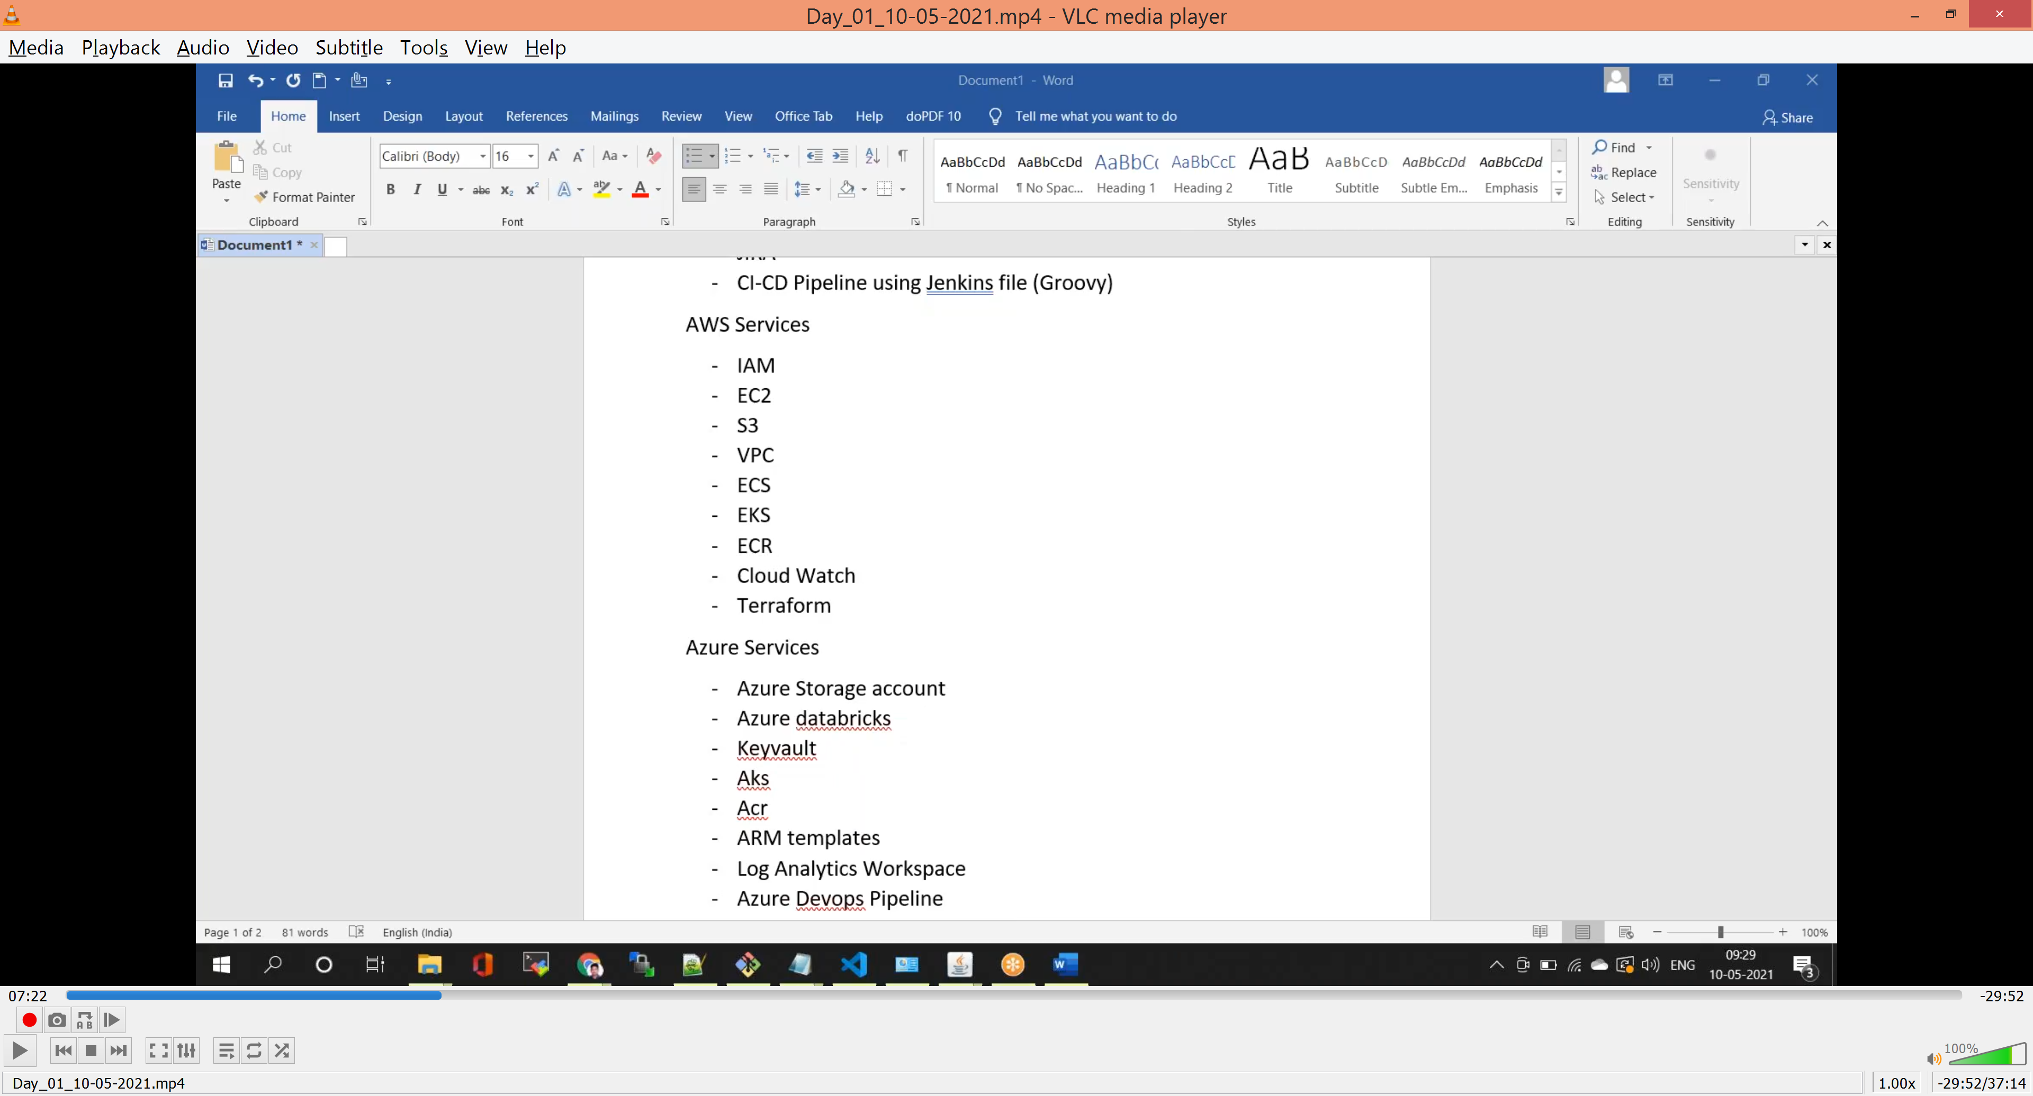

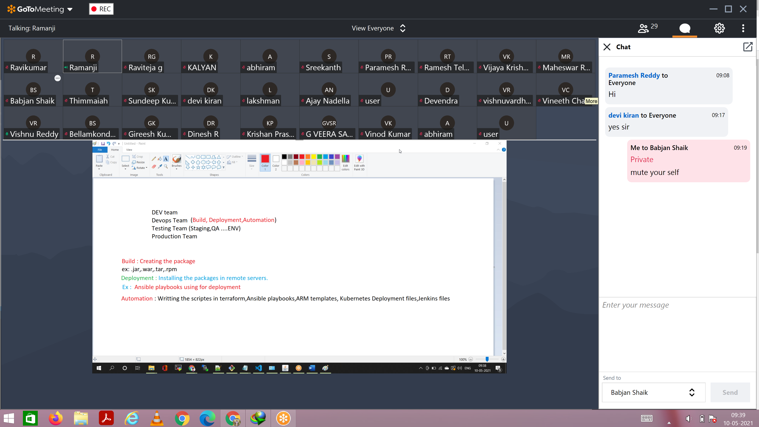

Build:-

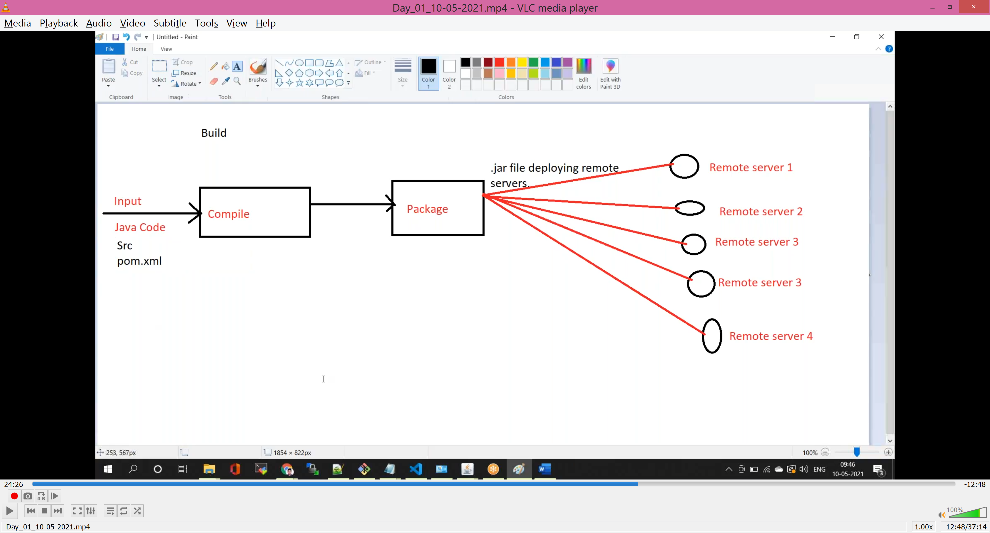

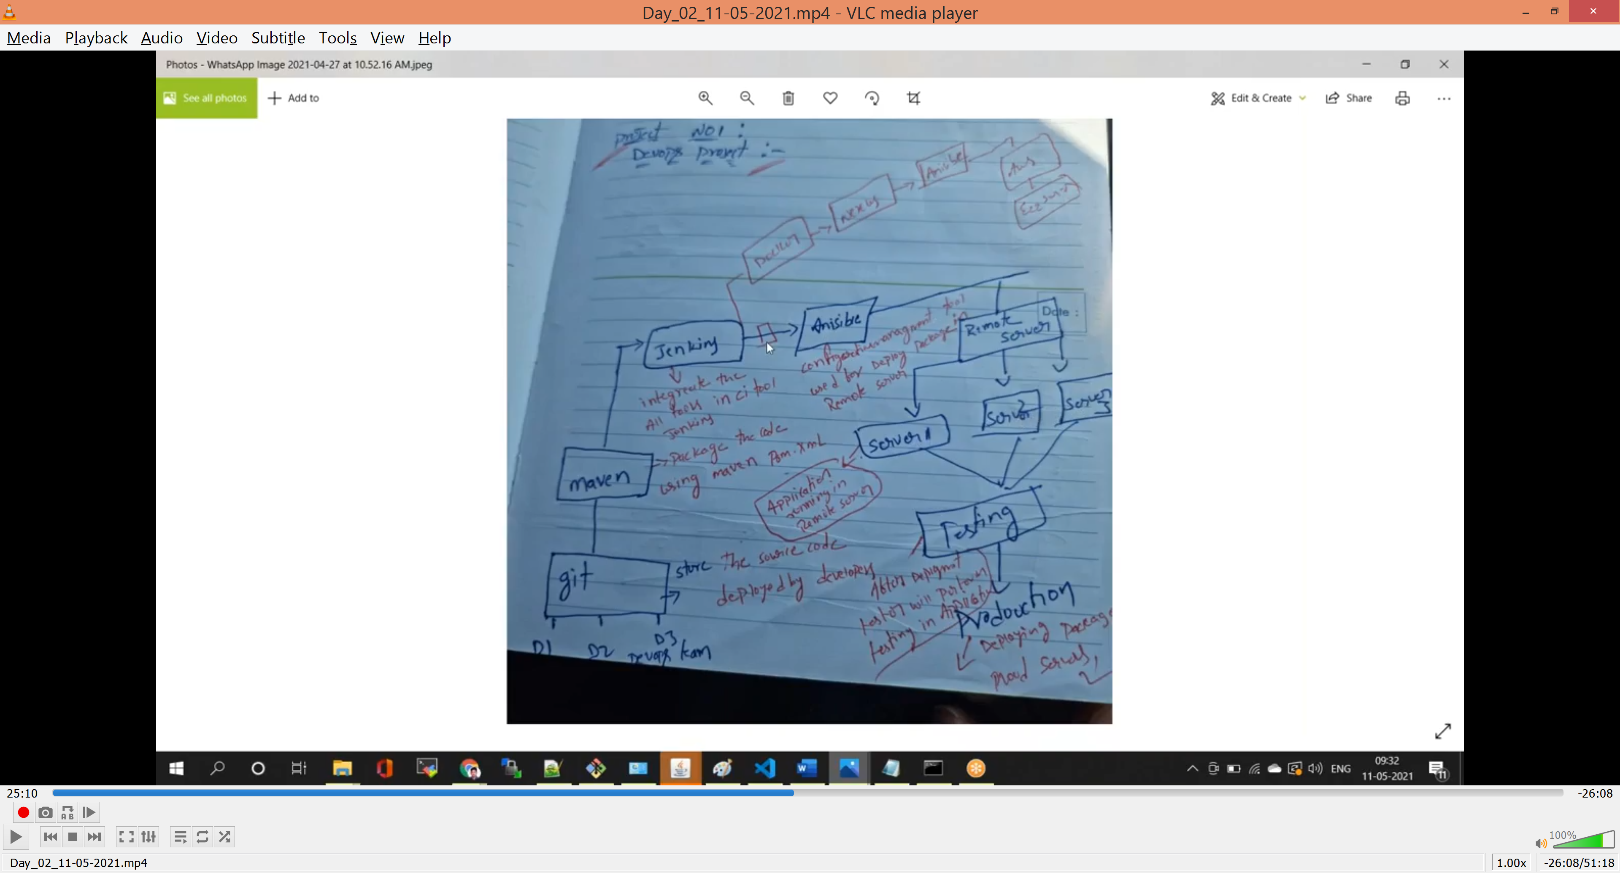

Configuration App:-

Puppet

Chef

Anisible

Rundeck

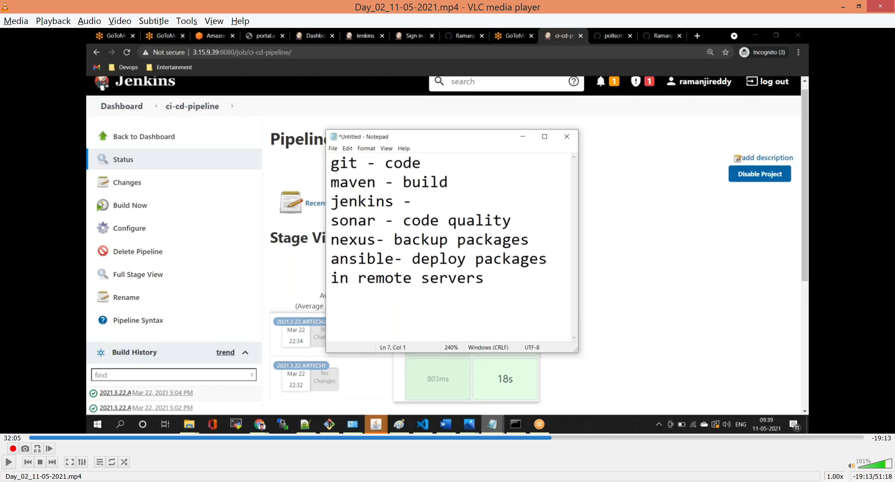

Git Commmands

- git clone <repositoryname> 'to clone the remote repository name

- git status 'to check untracked files status

- git add 'to add the untracked files

- git log 'to check history of logs

- git diff 'to see difference between two changes

- git checkout -b <newbranchname> 'to create the new branch in git

- git branch 'to check the list of branches

- git delete origin <branch name> 'to delete remote branch

- git commit –m “<Message>” ‘to commit the changes

- git push origin master ‘push the changes from local to remote repository

- git merge

- git pull

- git fetch

- git pull request

- git reset

- git revert

- git stash

Git Repository

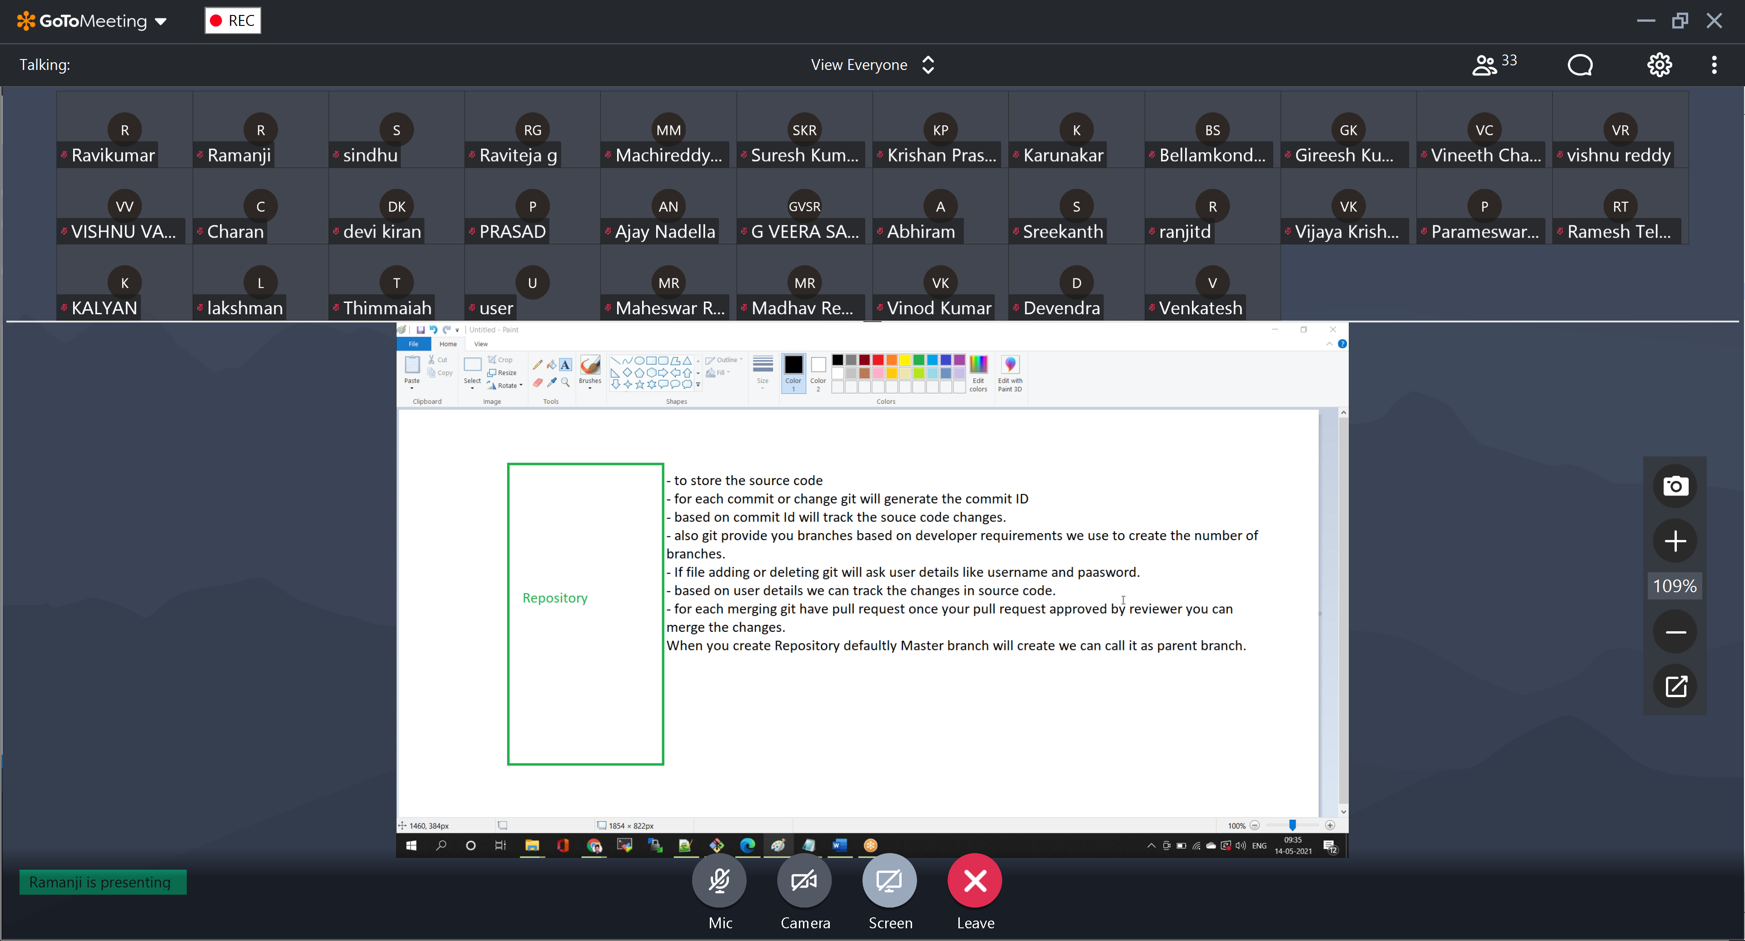

Interview Questions

Which architecture / which registry you are using

Nexus (to store .jar, .war, .tar, docker images) / Docker Hub (for only docker images)

What type of EC2 servers you are using?

For different environments different size servers we are using, its completely based on the business requirement.